**“VEHICLE INSURANCE”**

**MINOR PROJECT REPORT**

***Submitted by***

**Somya Jain**

**Enroll No.:0206CB131159**

**Shifa Tasleem**

**Enroll No.:0206CB131132**

***in partial fulfillment for the award of the degree***

***of***

**BACHELOR OF ENGINEERING**

***in***

**COMPUTER SCIENCE AND BUSINESS SYSTEM**



**DEPARTMENT OF COMPUTER SCIENCE AND ENGINEERING**

**GYAN GANGA INSTITUTE OF TECHNOLOGY & SCIENCES**

**JABALPUR (M.P.)**

**RAJIV GANDHI PRODYOGIKI VISHWAVIDYALAYA,**

**Bhopal(M.P.)**

#### *CERTIFICATE*

**This is to certify that the Minor Project Report entitled “VEHICLE INSURANCE” submitted by Somya Jain, Shifa Tasleem has been carried out under my guidance & supervision. The Minor project report is approved for submission towards partial fulfillment of the requirement for the award of degree of BACHELOR OF ENGINEERING in COMPUTER SCIENCE & ENGINEERING from “RAJIV GANDHI PROUDYOGIKI VISHWAVIDYALAYA, BHOPAL (M.P).**

|  |  |
| --- | --- |
| **Prof. Amit Sahu** | **Dr. Ritu Ahluwalia** |
| **Guide** | **HOD** |
| **Dept. of Computer Science and Business System** | **Dept. of Computer Science and Business System** |

# 

***CERTIFICATE***

**This is to certify that the Minor Project Report entitled “VEHICLE INSURANCE” is submitted by Somya Jain , Shifa Tasleem for the partial fulfillment of the requirement for the award of degree of BACHELOR OF ENGINEERING in COMPUTER SCIENCE & ENGINEERING from “RAJIV GANDHI PROUDYOGIKI VISHWAVIDYALAYA, BHOPAL (M.P).**

**Internal Examiner External Examiner**

**Date: Date:**

# 

#### *DECLARATION*

**We hereby declare that the project Report entitled “VEHICLE INSURANCE” which is being submitted in partial fulfillment of the requirement for award of the Degree of Bachelor of Engineering in Computer Science and Engineering to “RAJIV GANDHI PROUDYOGIKI VISHWAVIDYALAYA, BHOPAL (M.P.)” is an authentic record of our own work done under the guidance of Mrs Yasha Dubey., Department of Computer Science & Engineering, GYAN GANGA INSTITUTE OF TECHNOLOGY & SCIENCES, JABALPUR..**

**The matter has not been submitted earlier for the award of any other degree.**

**Dated: Somya Jain**

**Place: JABALPUR. Shifa Tasleem**

##### 

*ACKNOWLEDGEMENT*

**We sincerely express indebtedness to esteemed and revered guide “*Proff Yasha Dubey mam*”, *Designation* in *Department name* for her invaluable guidance, supervision and encouragement throughout the work. Without his kind patronage and guidance the report would not have taken shape.**

**We take this opportunity to express deep sense of gratitude to “Mr. Ashok Verma”, Head of “Computer Science”for his encouragement and kind approval. Also we thank him in providing the computer lab facility. We would like to express our sincere regards to him for advice and counseling from time to time.**

**We owe sincere thanks to all the lecturers in “Computer Science*”* for their advice and counseling time to time.**

**Dated: Somya Jain**

**Place:JABALPUR Shifa Tasleem**

##### 

**TABLE OF CONTENTS**

ABSTRACT 8

1. INTRODUCTION 9

2. PROBLEM STATEMENT 9

3. SOFTWARE REQUIREMENTS SPECIFICATION 10

3.1 PURPOSE OF THE SYSTEM 10

3.2 SCOPE OF THE DOCUMENT 10

3.3 INTENDED AUDIENCE 10

4 .TEAM ARCHITECTURE 11

5. OVERALL DESCRIPTION 13

5.1 PRODUCT FUNCTION 14

5.2 ASSUMPTIONS AND DEPENDENCIES 15

6. SPECIFIC REQUIREMENTS 15

6.1 EXTERNAL INTERFACE REQUIREMENTS 15

6.1.1 USER INTERFACE 16

6.1.2 HARDWARE INTERFACE 16

6.1.3 SOFTWARE INTERFACE 17

6.1.4 COMMUNICATION INTERFACE 17

6.2 PERFORMANCE REQUIREMENTS 17

6.3. NON-FUNCTIONAL REQUIREMENTS 18

7. SOFTWARE SYSTEM ATTRIBUTES 19

8. SOFTWARE PROCESS MODEL 20

8.1 Why not Evolutionary models? 20

8.2 Why not Waterfall model? 20

8.3 Why Incremental RAD model? 20

8.4 OBSERVATION 21

9 DETERMINING PROJECT FEASIBILITY 22

10.DATABASE DESIGN 24

CUSTOMER 24

11.DESIGN MODELS 26

11.1 DATA FLOW DIAGRAM 26

11.2 USE CASE DIAGRAM 27

11.3 ER DIAGRAM 28

11.4 CLASS DIAGRAM 29

11.5 SEQUENCE DIAGRAM 30

12.SCREENSHOTS 31

# ABSTRACT

Write an abstract of your project.

# INTRODUCTION

Insurance purchased for CARS ,TRUCKS,MOTORCYCLES and other road vehicles.Primary use is to provide financial protection against physical damage or bodily injury resulting from traffic collision.Financial protection against theft of the vehicle and possibly damage to the vehicle.

A compulsory car insurance scheme was first introduced in the UK with the road Traffic Act in 1930.This ensured that all vehicle owners and drivers had to be insured for their liability for injury or death to third parties whilst their vehicle was being used on a public.

Several jurisdiction have experimented with a “pay-as-you-drive” insurance plan which is paid through gasoline tax (petrol tax).This would address issues of uninsured tmotorist and also charge based on the miles (km) driven, which could theoretically increase the efficiency of insurance.

CTP(Compulsory Third Party Personal Injury Insurance):Is a state based scheme that covers only personal injury liability and is linked to the registration of vehicle.

# 2. PROBLEM STATEMENT

Our application deals with the problems related toinsurance and provide easy accessibility of services to customers such as

* Terms and conditions should be up to the mark so that get the basic knowledge about it and atleast have a look to it.
* Customize the car insurance as per your needs .
* Option to choose the best Insurance for your car.
* No claim bonus protector.
* Avail zero dep plan for full claim settlement.
* Comprehensive support through our dedicated customer support team.
* Form should have simple vocabulary words so that it is easy understand- able by common people

# 3. SOFTWARE REQUIREMENTS SPECIFICATION

## 3.1 PURPOSE OF THE SYSTEM

The purpose of the system is to architect a simple VEHICLE INSURANCE software system and implement it, which later will be used for a web based application.

## 3.2 SCOPE OF THE DOCUMENT

The task of developing the document was distributed amongst the team members. The team divided itself into various worlds present in the Requirements Engineering scenario and thus played their part.

The team was responsible for gathering the requirements and represents them in the required format.

## 3.3 INTENDED AUDIENCE

This text belongs to all the team workers and is intended for the product in charge, GYAN GANGA INSTITUTE OF TECHNOLOGY AND SCIENCES and the users who want an easy access to various information regarding various modules of VEHICLE INSURANCE. This report contains the overview of the whole system in which each feature is examined according to the precedence.The expected audience of this document is the users of the Vehicle Insurance system and the developers.

# 4 .TEAM ARCHITECTURE

The team consists of 2 members:

MEMBER 1

MEMBER 2

The work is broken down as follows:

**MEMBER 1**

WORKS AT DATABASE SIDE:

* Backend
* Reports
* Administration

**BACKEND PROCESSES:**

* Renewal Alerts: A backend batch process will be running in the background that will monitor policies that are about to expire and issue alerts to the policy holder to renew the policy.
* Monthly Payments: Collection of Monthly payment from the clients – sending reminders, processing payments, charging defaulting fees, etc.

**REPORTS:**

Sales reports

Customer trends

**ADMINISTRATIONS:**

This is the screens to add new Base Rates and new Factors which are subjected to change according to the insurance company.

Note:-Effective Date of Policy can be up to 60 days from Date of Issue of Policy.

**MEMBER 2:**

WORKS FOR CUSTOMER:

Client Info Screen

* Name
* Date of Birth
* Gender
* License number
* Date of purchasing vehicle
* Vehicle number
* Email Address
* Address

**INFORMATION FOR CUSTOMER:**

Summary Page

Issue Page

Payment Page

**Summary Page:**

Display the selected Plan and All information Entered By Client

**Issue Page:**

Display the selected Plan

All information Entered by Client

Display Policy Number

**Payment Page**:

All Information Required for Credit Card Payment Amount

**Payment Engine:**

Through Payment Engine the Payment for the VEHICLE INSURANCE policy is made through credit cards through Internet.

# 5. OVERALL DESCRIPTION

A simple Insurance system has to be architected which will later be used as a web based application. The project will use Object-Oriented architectural style, which will be accessible through a web page.

The Vehicle Insurance is looking at leveraging the powers of the internet to increase its business to sell their insurance products over the internet via a website. The system is required to track how the client has arrived at the website since this would be required to calculate commission for agents who have directed clients to our website.

## 5.1 PRODUCT FUNCTION

This section describes the general functionality of the system being developed which will be discussed in detail in the coming sections.

The functionalities to be satisfied by the system can be broadly classified in the following ways:

Accept Input

In this application we accept following inputs

1) Accept customer information like

* Name
* Date of Birth
* Gender
* Email
* Address

Processing

Based upon the client inputs about the demographics, a set of applicable policy plans is presented to the clients to choose from. The client chooses from these plans and applies for the policy. Based on the client answers to the vehicle related questions, policy is mandated to the client from registered agents of the agency. These results and in some cases the answers to the questions themselves also drive the decision whether or not the policy is to be issued to the client.

Output

Once both parties agree to the premium rates, policy coverage/benefits etc., the Policy is issued to the client. Once the policy is issued, the payment mode/cycle of the client is decided.

## 5.2 ASSUMPTIONS AND DEPENDENCIES

1. Input:

The client information should be valid and legal.

2. Processing:

The client may or may not reference by an agent. Report of client is informed by agent.

3. Output:

The output is displayed to the user. The user will not be able to edit the output.

# 

# 6. SPECIFIC REQUIREMENTS

## 6.1 EXTERNAL INTERFACE REQUIREMENTS

The interfaces in this section are specified by documenting: the name and description of each policy, source or input, destination or output, ranges, accuracy and tolerances, units of measure, timing, display formats and organization, and data formats.

### 

### 6.1.1 USER INTERFACE

The user interface required to be developed for the system should be user friendly and attractive. The interface between the user and the system will be WIMP (Windows, Icons, Menu, Pointers) keeping in mind that the system is to be run through web browser. All operations will be of point and click nature with all navigations performed through windows of the system specifically buttons and menus:

*Buttons:* The button is activated when the user will click with the left click of the mouse within the bounds of the button. And thus the action associated with it will be carried out.

*Menu:* All the operations will be arranged.

### 6.1.2 HARDWARE INTERFACE

Here's What You Need to Use the Vehicle Insurance system:

* 20 GB HDD
* 256 MB RAM
* Processor:Intel core TM i3 CPU
* System type:64 bit Operating System
* Input Devices: Keyboard, Mouse
* Output Devices: Monitor, Printer

### 6.1.3 SOFTWARE INTERFACE

* Programming Language Java
* Back Hand Tool Microsoft SQL Server 2008
* Supporting Tools Microsoft @ Word 2007

Microsoft @ PowerPoint 2007

### 6.1.4 COMMUNICATION INTERFACE

The Vehicle Insurance system is three-tier architecture. The client is a thin client who just displays the forms to the user of the system. The database tier stores all the information (characters, lines, etc) in a table. The middle tier does all the transactions and processing of the system. It does the communication between the thin client and the database

## 6.2 PERFORMANCE REQUIREMENTS

The system will process incoming data and send relevant feedback within a few milliseconds of receiving it. Web users may not be able to have such a fast response as this however, because of bandwidth limitations, especially during peak usage times. The system will also be capable of dealing with large number of users (approx. 1000) simultaneously. Given that expanding nature of the World Wide Web, the above scenario would not be uncommon. The system will be able to maintain response times that are within the normal expectations of a user even during periods of heavy usage.

## 6.3. NON-FUNCTIONAL REQUIREMENTS

* Performance Criteria:
* Time

The elapsed time between the submission of documents process between client to agent that between agent to company should be as minimum as possible.

Similarly, there is being a minimal gap between the circular shifting of the documents of all information about client.

* **USER FRIENDLY:**

Our vehicle insurance system should be more users friendly. The user interface should be kept simple and uncluttered. Since different type of people will interact in this process so our project should be very easy to them to understand.

* **FLEXIBILITY:**

Our project should be so flexible that whenever we want to make changes in it very easily it can be done.

* **EXTENSIBILITY**:

It should be able to accommodate the variations like:

-- Different policies should be handled easily.

-- Client interaction after sending his/her details.

-- It should be able for direct money transfer from one place to another.

* **PORTABLE:**

Our project should be portable on any platform and available on and at a faster speed than others.

* **REUSABLE**:

All the client web pages that are being used for client information should be easily get processed so that many clients can interact with us very easily and very fast without any information destroy.

# 7. SOFTWARE SYSTEM ATTRIBUTES

* **RELIABILITY:**

The vehicle insurance process on the project should be easy and without any mistakes so that clients should take information about all the policies and their interest rate and update by company should be very easy and safe.

* **AVAILABILITY:**

The project should be available 24 hours a day, 7 days a week. The availability can be measured in terms of MTTR (Mean Time To Repair) and MTBF (Mean Time Between failures). The system will be available to the user whenever the user needs it.

* Maintainability:

Our project should be easy to maintain by administrators or by our company. After certain of time system should be added a new policies and our user interactive schemes so that we can deal with our users according to market and time.

# 

# 8. SOFTWARE PROCESS MODEL

## 8.1 Why not Evolutionary models?

These models are best suited where requirements are fuzzy. These models are best suited for the systems where requirements keep on changing. But for our system requirements are crystal clear so it is not feasible to adopt any of the evolutionary models.

## 8.2 Why not Waterfall model?

Waterfall model can be adopted in our case because requirements are known in advance but there are some limitations of waterfall model due to which it is not feasible to adopt:

* No parallelism of work.
* Time consuming

## 8.3 Why Incremental RAD model?

Incremental model is advisable where requirements are clear and the development time is less. The striking feature of incremental model is that each module can be completed and released as and when requirement arises because of lack of time.

As in our system many of the modules are not inter-related so can be released in isolation. The user can thus get a feel of these modules and give his feedback which can be utilized for making the software more user friendly and in line with the user requirements.

Not only that the deadline set for this project is 3 months and we need a high adaptation model and again will be concentrating on parallelism because our team will be working on different module on same time. Moreover we will be using latest tools as a result of which we can work much faster. So looking into all these requirements we find Incremental RAD model is best suited for our system because it enables the development team to create a fully functional system within very short period of time.

## 8.4 OBSERVATION

We have observed that our system that is Inventory Management and Costing would be of immense help to the client as currently everything is done manually, which results in a lot of time consumption, is error prone and also increases economic burden in the form of salaries paid to the workers. Moreover such a manual system of managing inventory is quite unstructured. Our system would be efficient, accurate and easy to use and requires very less labor.

# 9 DETERMINING PROJECT FEASIBILITY

The feasibility study is not a full-blown systems study. Rather, the feasibility study is used to gather broad data to make a decision on whether to proceed with system study. System project feasibility is assessed in three principal ways:

* Economically
* Technically
* Operationally
* **ECONOMICAL FEASIBILITY:**

The organization has evaluated cost of software and hardware required for the system including the storage of data. The benefits expected from the system are studied to assess the reduced cost due to the new system.

* **TECHNICAL FEASIBILITY:**

Organization has shown willingness to purchase all hardware and software tools which we recommend to successfully implement the system. Hence technically there are no limitations for the development of the system. As far as programming efforts are concerned, we are familiar with Java and SQL Server, Thus the project is technically feasible.

* **OPERATIONAL FEASIBILITY:**

Operational feasibility is dependent on the humans who will be using the software once it’s ready and installed for use. The software will have a user friendly interface which will be much convenient as compared to the current manual procedure. Thus the project is operationally feasible.

**EXISTING SYSTEM**

As we know the manual existing system is quite tedious, less accurate and time consuming in comparison to computerized system. Obviously the present system is not exception consultant encountering all the above problems:

1. Less accurate.
2. Time consuming.
3. Very tedious.
4. Lot of paper work.
5. Slow data processing.

# 10.DATABASE DESIGN

## CUSTOMER

|  |  |  |
| --- | --- | --- |
| Field Name | Data type | Constraints |
| Cust_Id | Int | PK |
| Agent _Id | Int | FK |
| C_Name | varchar(50) | NN |
| Contact | Int | NN |
| Gender | Int | NN |
| EmailId | Varchar(50) |  |
| Address | String | NN |
| City | String | NN |

**Agent**

|  |  |  |
| --- | --- | --- |
| Field Name | Data type | Constraints |
| Agent _ID | Int | FK |
| Agent_name | varchar(50) | NN |
| Contact | Int | NN |
| EmailId | Varchar(50) |  |
| User_id | String | NN |
| Password | varchar | NN |

**INSURANCE**

|  |  |  |
| --- | --- | --- |
| Field Name | Data type | Constraints |
| A_name | String | PK |
| C_name | String | FK |
| Policy | String | NN |
| Company | String | NN |
| Model | String | NN |
| Year_of_manu | Int | NN |
| Start_of_Policy | LongInt | NN |
| End_of_Policy | LongInt | NN |
| Expctd_cost | Int | NN |
| Insu_cost | Int |  |
| Amt_paid | Int |  |
| Rem_Amt | Int |  |

# 11.DESIGN MODELS

11.1 DATA FLOW DIAGRAM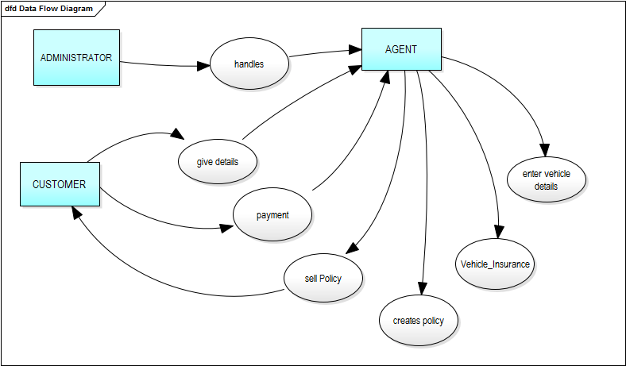

11.2 USE CASE DIAGRAM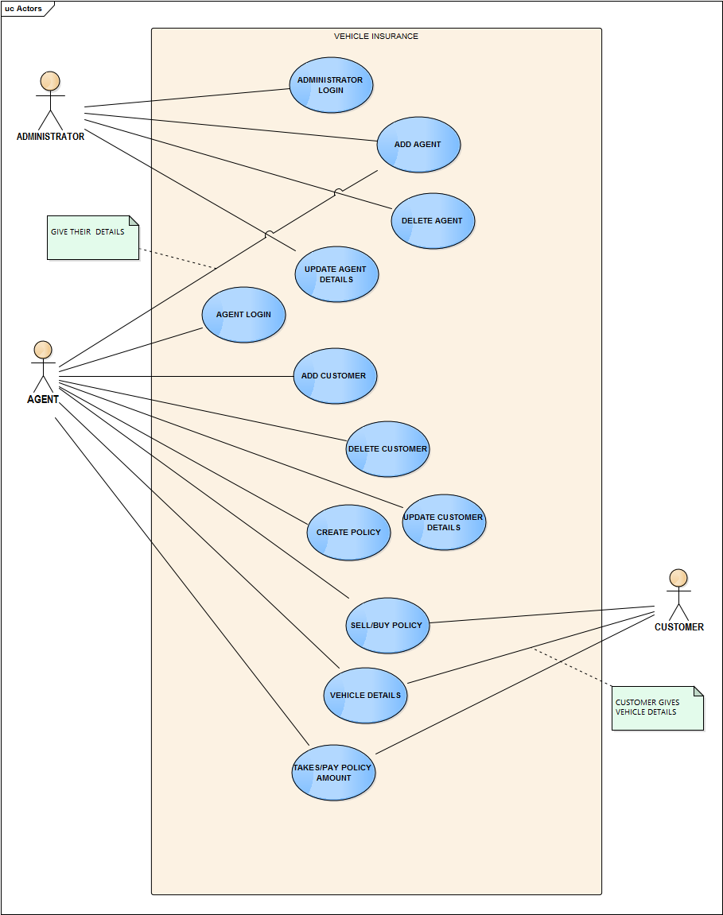

## 11.3 ER DIAGRAM

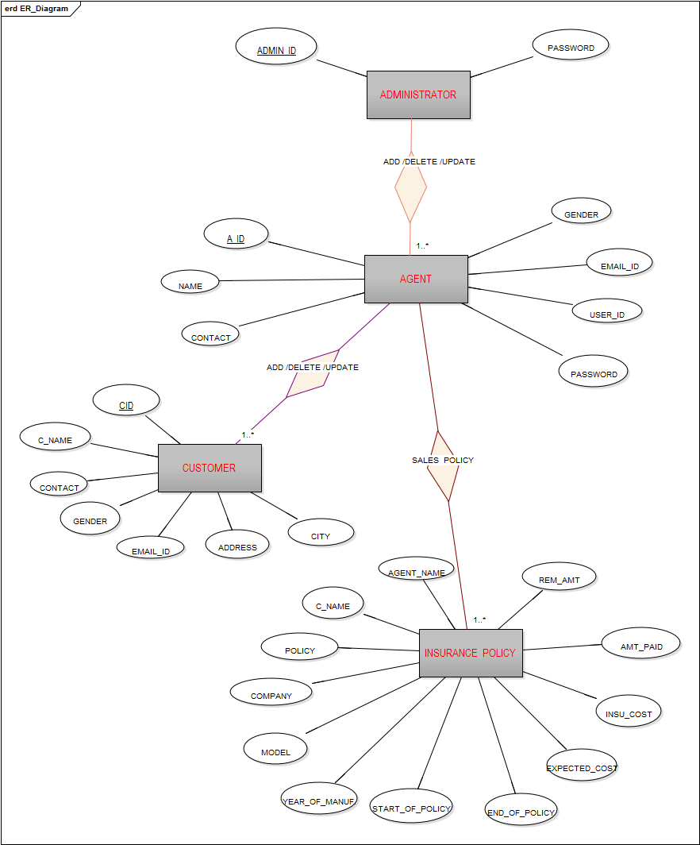

## 11.4 CLASS DIAGRAM

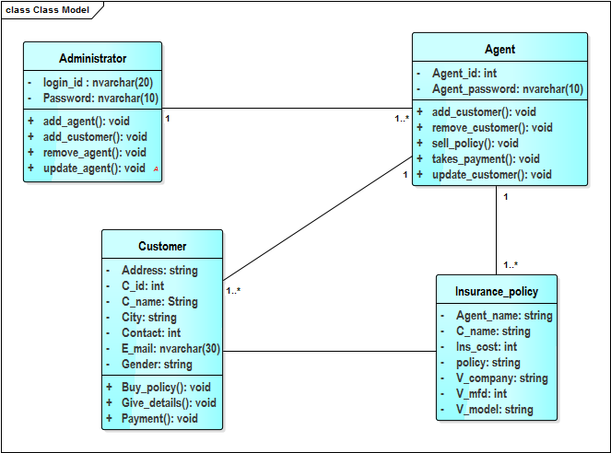

## 11.5 SEQUENCE DIAGRAM

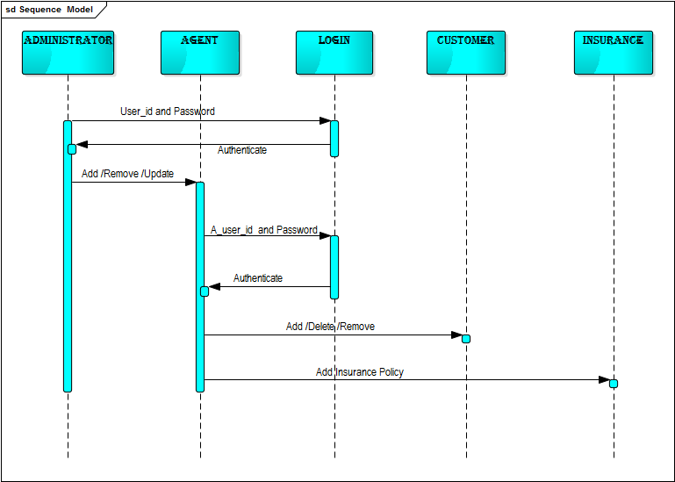

12.SCREENSHOTS 